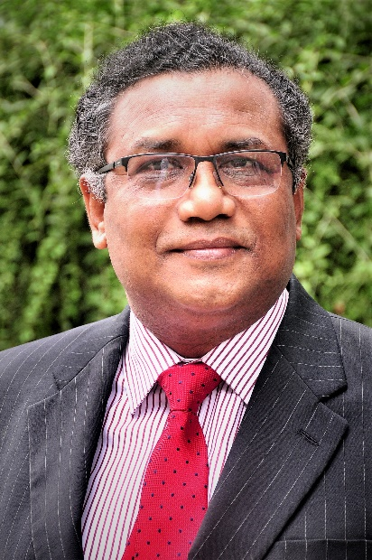
NAME: Borhan Uddin Khan

DESIGNATION: Professor

QUALIFICATIONS: PhD; LL.M; LL.B

APPOINTMENT(S): Advisor & Head of the Department of Law

EMAIL ADDRESS:

OFFICE TEL: +8802 8431645 Ext. 2481

OFFICE ADDRESS: Department of Law, Building 3, Independent University, Bangladesh (IUB)
Plot 16 Block B, Aftabuddin Ahmed Road, Bashundhara R/A, Dhaka, Bangladesh.

RESEARCH INTERESTS: International Law

SUBJECTS TAUGHT: Civil Procedure

BRIEF BIODATA:

RESEARCH & PUBLICATIONS:

RESEARCH FUNDING

